The heat sink of Raspberry Pi 3B is 1 copper and 1 aluminum, which is mounted in the Raspberry Pi position as shown below. The heat sink can not be reused after removing from the Raspberry Pi board.

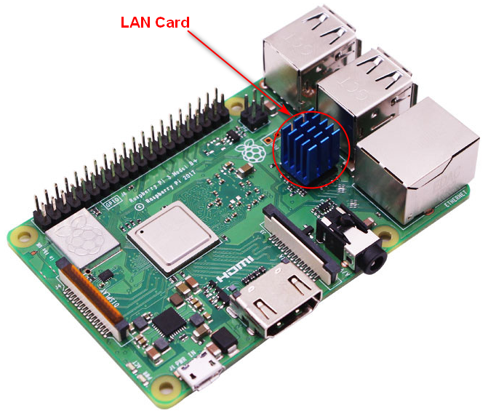

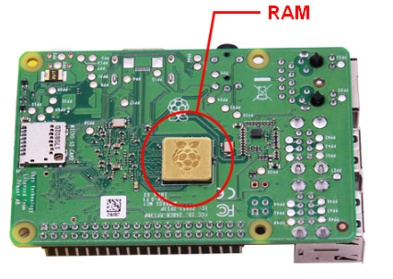

0-1

